Software Requirements Specification Document

Project : Sportyshoe.com
Developer : Jagasabarivel K

Revision History
Date | Version | Description | Author
09/03/23 | <1.0> | SSD 1.0 | Jagasabarivel K

Table of Contents
1. Introduction 4
1.1 Purpose 4
1.2 Scope 4
1.3 References 5
1.4 Overview 5
2. Overall Description 5
3. Specific Requirements 5
3.1 Functionality 5
3.1.1 Registration. 6
3.1.2 Login. 6
3.1.3 Admin Portal 6
3.1.3.1. Browse the list of users who have signed up and be able to search users 6
3.1.3.2. Manage the products in the store including categorizing them 6
3.1.3.3. See purchase reports filtered by date and category 6
3.1.4 User Portal 6
3.1.4.1. Sign-in to the application to maintain a record of activities 6
3.1.4.2. Search for shoe based on the search keyword 6
3.1.4.3. Add all the selected shoe to a cart and customize the purchase at the end 6
3.2 Usability 7
3.2.1 Rest Calls 7
4. Core Concepts Used 7
5. Code Location 7
6. Project Snapshot 8

Software Requirements Specification Document

Introduction

The aim of this document is to gather and analyze and give an in-depth insight of the complete Sportshoe.com by defining the problem statement in detail. Nevertheless, it also concentrates on the capabilities required by stakeholders and their needs while defining high-level product features. The detailed requirements of the Sportshoe.com are provided in this document.

Purpose

The purpose of the document is to collect and analyze all assorted ideas that have come up to define the system, its requirements with respect to consumers. Also, we shall predict and sort out how we hope this product will be used in order to gain a better understanding of the project, outline concepts that may be developed later, and document ideas that are being considered, but may be discarded as the product develops.

In short, the purpose of this Software Specification document is to provide a detailed overview of our software product, its parameters and goals. This document describes the project's target audience and its user interface, hardware and software requirements. It defines how our client, team and audience see the product and its functionality. Nonetheless, it helps any designer and developer to assist in software delivery lifecycle (SDLC) processes.

Scope

Primarily, the scope pertains to the file manager product features for making Sportshoe Pvt Ltd’s Sportshoe.com live. It focuses on the company, the stakeholders and applications, which allow for manage files.

This Software Specification is also aimed at specifying requirements of software to be developed but it can also be applied to assist in the selection of in-house and commercial software products. The standard can be used to create software requirements specifications directly or can be used as a model for defining a organization or project specific standard. It does not identify any specific method, nomenclature or tool for preparing an Software Specification.

References
The references are:

- Class room training from simplilearn.com

Overview

The remaining sections of this document provide a general description, including characteristics of the users of this project, the product's hardware, and the functional and data requirements of the product. General description of the project is discussed in section 2 of this document. Section 3 gives the functional requirements, data requirements and constraints and assumptions made while designing the E-Store. It also gives the user viewpoint of product. Section 3 also gives the specific requirements of the product. Section 3 also discusses the external interface requirements and gives detailed description of functional requirements. Section 4 is for supporting information.

Overall Description

This document contains the problem statement that the current system is facing which is hampering the growth opportunities of the company. It further contains a list of the stakeholders and users of the proposed solution. It also illustrates the needs and wants of the stakeholders that were identified in the brainstorming exercise as part of the requirements workshop. It further lists and briefly describes the major features and a brief description of each of the proposed system.

The following SRS contains the detail product perspective from different stakeholders. It provides the detail product functions of file manager with user characteristics permitted constraints, assumptions and dependencies and requirements subsets.

Specific Requirements

The specific requirements are –

Functionality

Introduction –

This subsection contains the requirements for the Sportshoe application. These requirements are organized by the features discussed in the vision document. Features from vision documents are then refined into use case diagrams and to sequence diagram to best capture the functional requirements of the system. All these functional requirements can be traced using tractability matrix.

Admin Portal:
- Browse the list of users who have signed up and be able to search users
- Manage the products in the store including categorizing them
- See purchase reports filtered by date and category

User Portal:
It deals with the user activities. The end-user should be able to:
- Sign-in to the application to maintain a record of activities
- Search for shoe based on the search keyword
- Add all the selected shoe to a cart and customize the purchase at the end

Registration.

Users shall be allowed to register themselves with the application with their name, phone and password.

Login.

The user shall login to the portal after registration.

Admin Portal

Browse the list of users who have signed up and be able to search users

Manage the products in the store including categorizing them

See purchase reports filtered by date and category

User Portal

Sign-in to the application to maintain a record of activities

Search for shoe based on the search keyword

Add all the selected shoe to a cart and customize the purchase at the end

Usability

Rest Calls

localhost:4200/login will allow user to login.

localhost:4200/register will allow user to register with the application.

localhost:8080/api/category/add will allow admin to add category.

localhost:8080/api/product/add will admin to add new shoe.

localhost:8080/api/customer/add will allow user to add the shoe to his cart.

localhost:8080/api/customer/view will allow user to view his cart..

Core Concepts Used
- Java
- Spring Boot
- JPA
- Spring Web
- H2
- Mvn
- Git

Code Location

https://github.com/JAGASABARIVEL/Java/tree/master/Back%20End%20Devops%20Project/Sportshoe

Project Snapshot

Register Portal
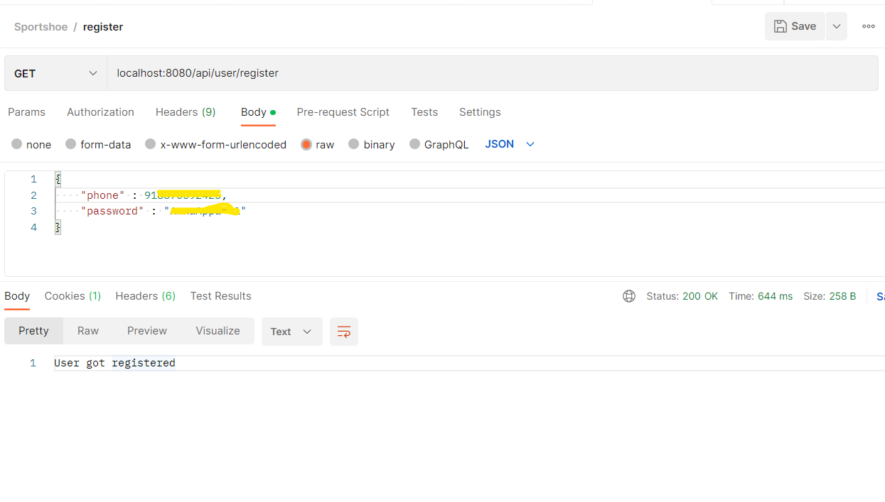

Login Portal
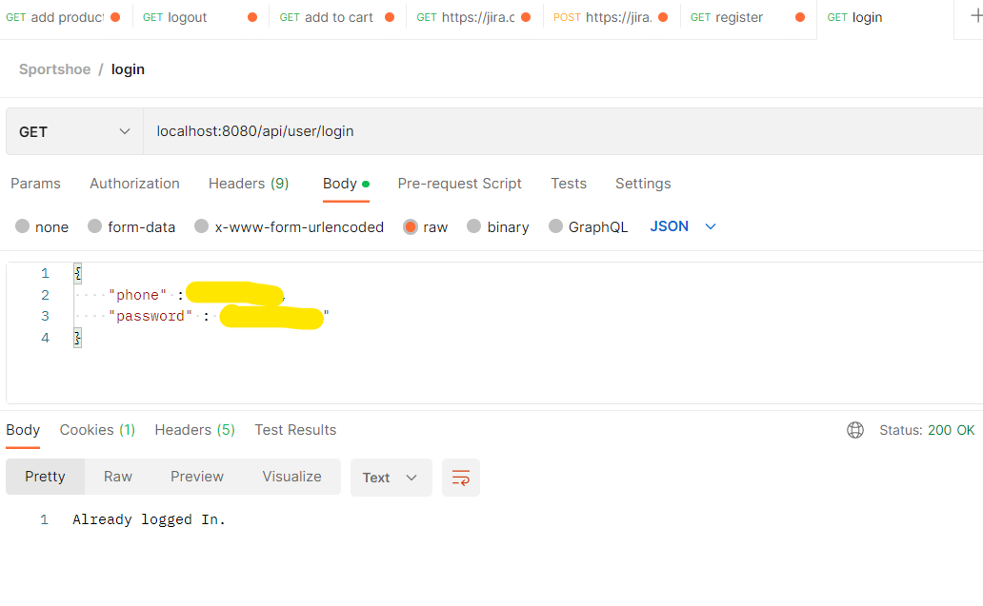

Admin adding category of shoe.
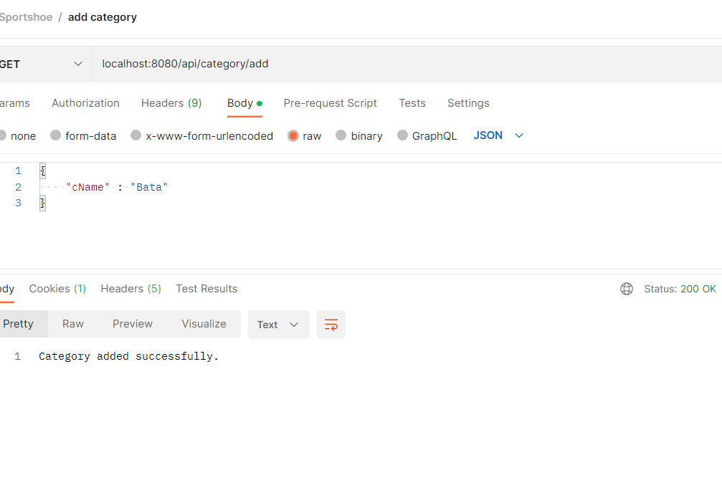
Admin add shoe product
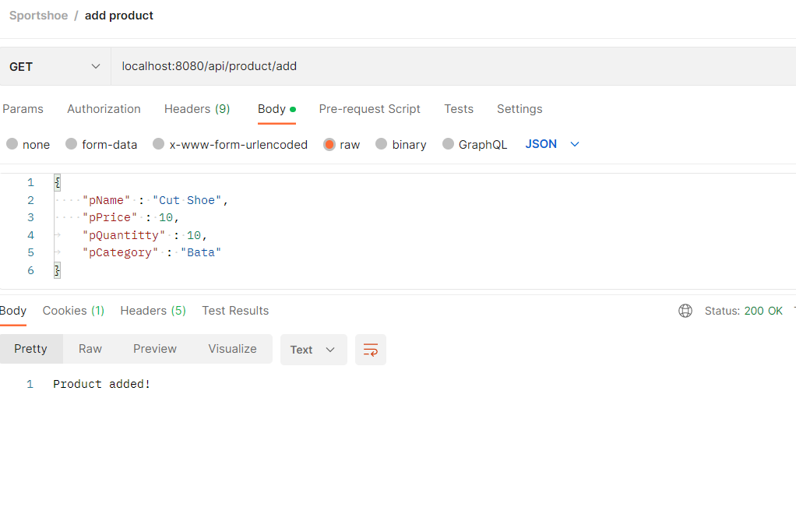

User add the the product to cart
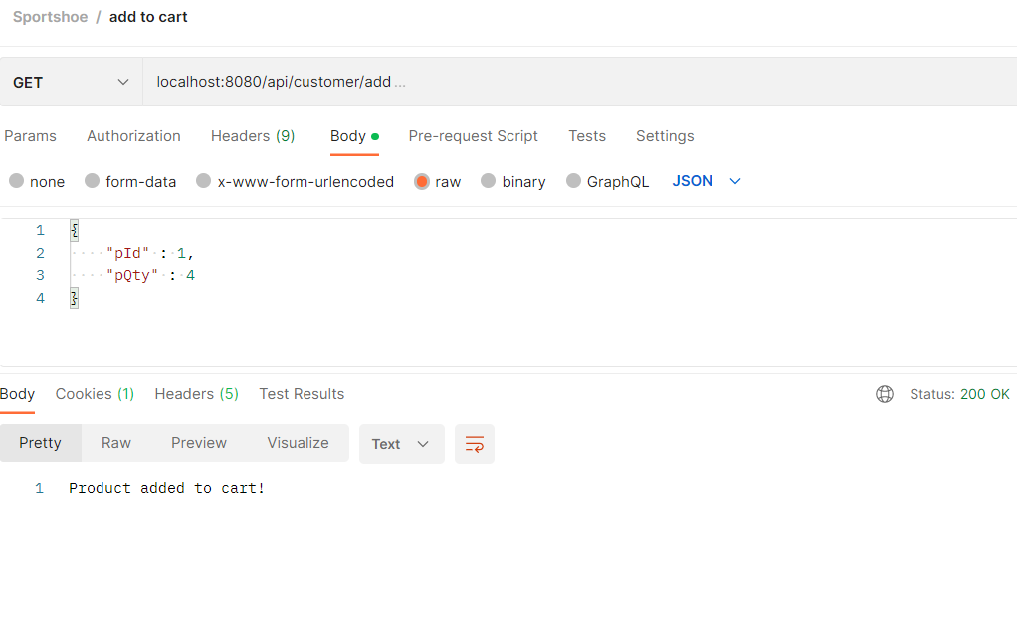

View cart

